

November 4th, 2023



**GROUP11 CREAT1VE 1NNOVATORS**

**Robotic Garbage Car**

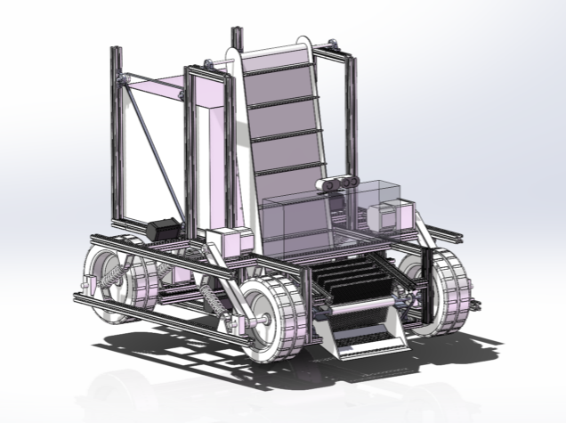

**Group members:**

Wenjun Cheng

Lianjie Yuan

Chenming Ge

Chengyuan Wang

Table of Contents

I. Abstract 3

II. Introduction 4

III. Problem 5

IV. Needs 5

V. Solution… [Project Name] 6

VI. Objectives 7

VII. Tasks 7

VIII. Schedule 10

IX. Budget 10

X. Key Personnel 11

XI. References 11

XII. Appendix 12

# Abstract

* The rapid economic growth and improved living standards have led to a significant increase in domestic solid waste (DSW), posing serious challenges for urban environments, particularly in university dormitories. This project aims to develop an intelligent dormitory garbage cleaning vehicle to address the pressing issues of waste management and sanitation within university campuses.
* The proposed solution involves the development of a compact garbage collection system, an automatic DSW sorting machine, multi-function garbage collection systems, and the integration of smart technologies for waste management. The significance of this solution lies in its potential to not only enhance waste management within university dormitory but also serve as a model for broader communities. The solution is expected to have a substantial social and environmental impact by improving cleanliness and waste management efficiency in dormitories and public spaces.
* The proposed intelligent dormitory garbage cleaning vehicle consists of six main parts: caterpillar, garbage collection box, track bracket, baffle, storage box, chassis, and wheels, with a garbage recognition camera integrated into the collection box. The project objectives include the development of a more compact and efficient garbage collection system, an automated DSW sorting machine, versatile garbage collection systems, and the integration of smart technologies such as IoT devices and data analytics for dynamic waste management. The project tasks encompass purchasing materials, designing the prototype, assembling components, applying the OpenCV graphic model, revising the obstacle avoidance program, testing and improving the prototype, preparing materials for the design expo, and writing comprehensive reports documenting the development process and results.

# Introduction

Our team, consisting of four members - Wenjun Cheng, Lianjie Yuan, Chenming Ge, and Chengyuan Wang, was founded with a shared objective: to innovate products that enhance people's living standards. Through careful observation of our daily lives, we identified a pressing need for an automatic garbage collecting car that could address the significant challenges faced by urban environments. In response to this need, we have embarked on a mission to design a more compact and efficient structure for garbage collection, leveraging the advancements in artificial intelligence (AI) technology. Our ultimate goal is to contribute to the improvement of urban living standards and create a cleaner and more sustainable environment.

By focusing on the development of an intelligent dormitory garbage cleaning vehicle, we aim to revolutionize waste management practices within university campuses and beyond. With our expertise and dedication, we seek to overcome the limitations of traditional waste collection methods by implementing a system that optimizes space requirements, effectively collects and sorts different types of waste, and integrates smart technologies for enhanced efficiency. We believe that our innovative solution has the potential to not only improve cleanliness and waste management within dormitory settings but also serve as a model for broader communities, promoting sustainable waste management practices and creating a positive social and environmental impact.

# Problem

# The rapid growth of the economy and great improvement of people's living standards makes the increasing domestic solid waste (DSW) becoming a one of the most serious challenges for city and regional environment nowadays. As a microcosm of the society, the scrutiny into the alleviation of DSW among university students holds the potential to furnish not only strategic recommendations for enhanced waste management within the campus precincts but also to exemplify a demonstrative effect for broader communities. According to Pan’s research of domestic solid waste at university dormitory in Shanghai in 2022, the mean waste generation was 0.275 kg/day/cap [1].

Due to the significant shift in the depth of knowledge, more flexible schedules, and the heavy academic workload, undergraduate students, especially freshmen in top universities, like Shanghai Jiao Tong University (SJTU), always have tight time schedules nowadays, which maybe one of the factors that why they can hardly spare their time cleaning their dorms. litter is frequently scattered, resulting in unsanitary living conditions in dorm and the breeding of pests like cockroaches. According to Simpeh’s research in 2020, “refuse collection and cleaning” was considered one of the most important services needed in college accommodations [2].

To address the problem, most students would place a trash bin under the table. However, the rubbish, like plastic bottles and used napkin, are easy to be left on the table and drop on the floor. Additionally, the trash bin tends to fill up quickly, increasing the likelihood of spillage.

Because the call of environment protection, Shanghai and other Chinese cities’ government have issued the garbage sorting policy [4]. However, some students didn’t follow the trend and ignored the trend. In Zhang’s study in 2017, 47% of the college student participants mixed all the DSW at source, which is a high rate compared to their friends (43%) and their parents (27%) [3]. However, college students are with “predominantly positive recycling attitudes” in Kelly’s study [5]. So, why do college students support the garbage recycling policy and attitude, yet mix their rubbish together? Again, the time shortage of college students plays a role in it.

Some top universities, like SJTU, has adapted several methods to overcome the obstacle. In our dormitory building, dorm supervisor will seek for plastic bottles and abandoned shipping box on the first floor. However, if students don't engage in source separation of waste, the entire garbage sorting process becomes futile. Therefore, there is a need for automatic garbage sorting and collection in dorms to save time and effort for college students.

The garbage in the dormitory of college students has a special structure of different types. For college students’ domestic waste in dorms, residual waste comprises 64% of the total, followed by household food waste at 29%, and recyclable waste at 7% in Pan’s study [1]. As the study was completed in the COVID-19 lockdown, when students couldn’t go to dining hall, household food waste might be overestimated, so the main garbage classification task in dorm is to identify the residual waste and the recyclable waste.

Take a step further, the problem of garbage collection and sorting still exists in some public areas. Public parks, streets, tourist spots, and museums face an even more severe problem compared to university dorms due to a scarcity of trash bins and a lack of public awareness about health and cleanliness.

**In summary, although garbage sorting policy has released and college students have the awareness of rubbish collection, today there is:**

1. **dirty and messy environment in dormitory because of rubbish everywhere**
2. **Shortage of time for students to collect and sort DSW**
3. **Poor sorting of solid waste in dorms**
4. **Lack of alternative ways to collect and sort waste**

# Needs

Because of the contradiction between student enrollment expansion and insufficient dormitory, some of dorms are narrow in some Chinese universities, while a disorderly and unclean environment causes the narrowing of the pathways within the dormitory worse. Hence, there is a need for a more compact garbage collection system to address the challenges posed by the limited space and to maintain cleanliness.

As mentioned in the following paragraphs, there is a shortage of time for college students to collect rubbish, which means that college students won’t spend much time thinking about rubbish collection. This has prompted a demand for easier garbage collection systems so that college students won’t spend more time on the trivial thing.

University dorms generate various types of solid waste, including recyclables, organic waste, and general waste. An easy-to-use waste collection system capable of handling different types of garbage is necessary to address the specific waste diversity present in university dorms.

Because of lack of alternative ways to collect and sort waste, there still exists a need for creative or alternative approaches to gathering waste beyond conventional means, possibly exploring technological solutions or unconventional methods. Also, There's a requirement for improved methods of sorting waste, indicating a desire for alternatives that are more effective, environmentally friendly, or resource-efficient.

**In short, to solve these problems in rubbish collection and classification, several new tools are required including:**

1. **a more compact garbage collection system**
2. **Automatic machine that can collect and sort DSW**
3. **Easy systems that can collect different types of garbage in different modes**
4. **Alternative ways to collect and sort waste**

# Solution… [Project Name]

We have designed an intelligent dormitory garbage cleaning vehicle with precise calculation analysis and proposed verification. The project includes:

1. Detailed modeling of the main structure of the car

2. Accurate identification of ground waste

3. Cleaning of ground waste (using cans as an example)

The proposed dormitory garbage cleaning vehicle is shown in Figure 1. It consists of six parts: caterpillar, Garbage collection box, Track bracket, baffle, Storage box, Chassis, and wheels. The Garbage collection box includes a garbage recognition camera, as shown in Figures 2 and 3.



Figure 1: Modeling of Dormitory Garbage Cleaning Vehicle 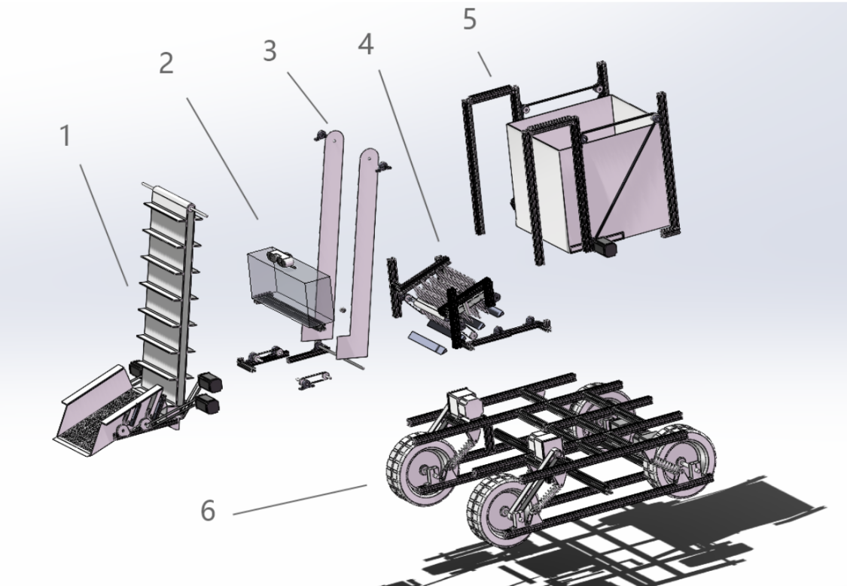

Figure 2: Modeling diagram of various components of dormitory garbage cleaning vehicle

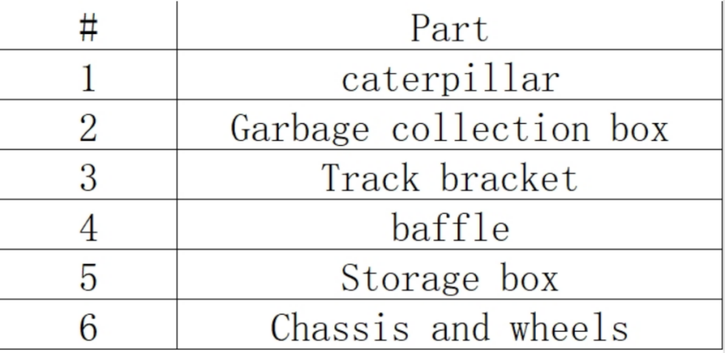

Figure 3: Table of Components of Dormitory Garbage Cleaning Vehicle

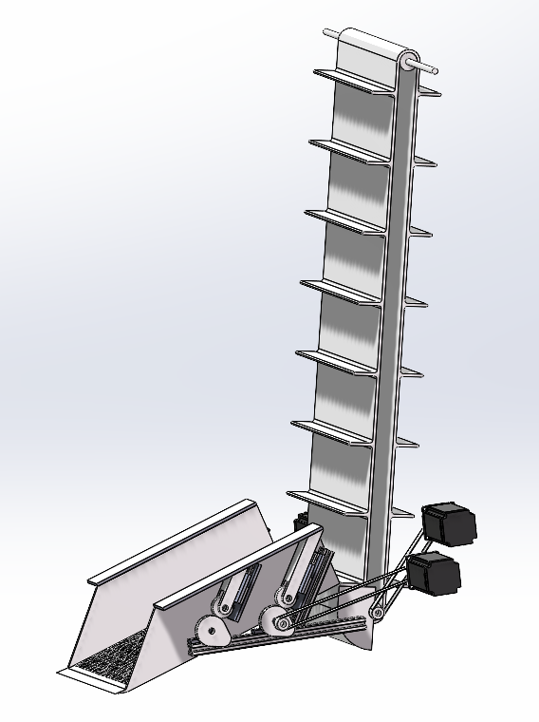

1. Caterpillar

Its function is to receive garbage and transport it to the garbage basket behind the car through tracks.

The material of the track is carbon fiber cloth, and all other materials are 3D printed.

Among them, we use two stepper motors to provide power to the track. In order to save electricity, the track will not rotate continuously. We install an ultrasonic sensor on one side of the track, and whenever we detect garbage entering, we will activate the track to rotate clockwise and transport the garbage to the trash basket. After transportation, rotate counterclockwise to return the track to its original position.

We have decided to reduce the partition to one, reducing its volume without changing its original function. However, this also allows the tracks to transport only one piece of garbage at a time, which we have addressed in other components.

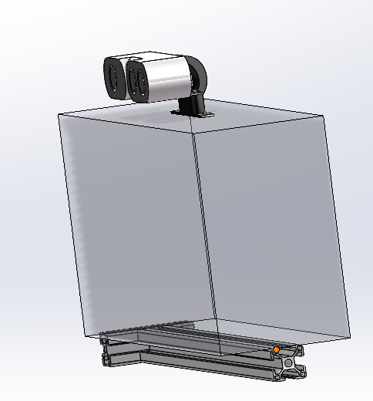

1. Garbage collection box

Its function is to store excessive waste, as the track can only transport one piece of waste at a time.

Its material is acrylic board, transparent, allowing for the observation of any excess waste inside. It is equipped with a camera to detect and identify garbage.

We have adopted the camera kit from the K210 development board, which can more accurately distinguish garbage through color differences.

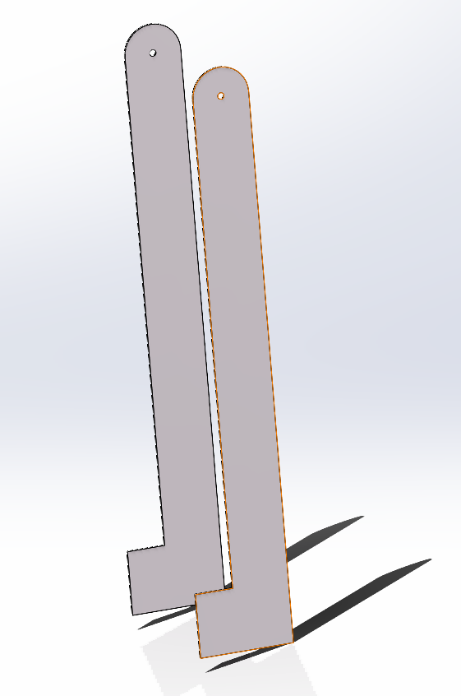

4.Baffle

Its function is to transport garbage from the ground to the baffle of the track.

Its material is 3D printing.

We have decided to change the track type to an excavation type, imitating excavators to pick up garbage from the ground and deliver it to the tracks. We use a stepper motor to provide power for excavation. This reduces the volume without changing the original functionality.

3.Track bracket

Its function is to fix the track and serve as a support for various parts.

Its material is 3D printing.

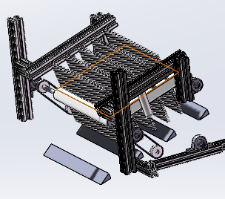

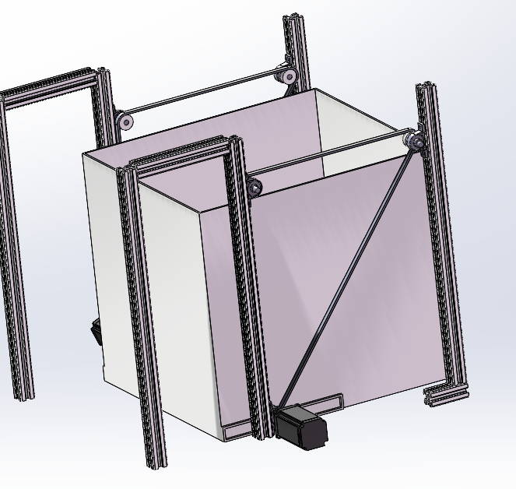

5.Storage box

Its function is a garbage receiver, collecting garbage.

Its material is acrylic board, and the bracket is 3D printed.

We plan to put on a garbage bag so that when all the garbage is collected, it can be directly packed and taken away.

We have decided to give up the function of garbage dumping, considering the height of the garbage bin, it is better to directly make it a garbage bin.

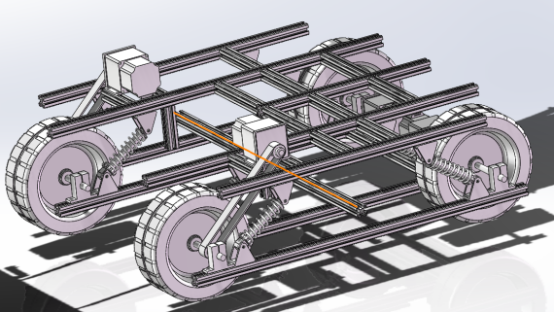

6.Chassis and wheels

Its function is to support the overall structure of the car and drive the car.

The wheels and motors are made of the same materials as Project 1, while the chassis is 3D printed.

The hollow chassis structure can reduce weight

# Objectives

* Objective 1: Compact Garbage Collection System Development:

Design and implement a more compact and efficient garbage collection system that minimizes space requirements and optimizes waste storage. This system should be easily deployable in university dormitorys with limited space.

* Objective 2: Design an Automatic DSW Sorting Machine:

Engineer an automated machine capable of efficiently collecting and sorting Dry Solid Waste (DSW) materials. This machine should incorporate advanced sensors and sorting mechanisms to accurately classify different types of waste, enhancing the overall efficiency of the recycling process.

* Objective 3: develop versatile Garbage Collection Systems:

Develop versatile garbage collection systems that can adapt to different types of waste and collection scenarios. These systems should be easily configurable to collect specific types of waste in various modes, such as bulk collection for larger items and precision collection for smaller, segregated items.

Objective 4: Integration of Smart Technologies for Waste Management:

Integrate smart technologies such as Internet of Things (IoT) devices and data analytics into waste management systems. Develop systems that can monitor and manage waste collection routes dynamically based on real-time data, optimizing collection schedules and routes for maximum efficiency.

# Tasks

1. Purchasing Materials

In this process, we need to identify and procure necessary components for the robotic cars. The singlechip casting the role of the processing unit shall be decided, and we need to research and select appropriate sensors, motors, cameras that meet the demand. Besides these functional components, we will mainly employ 3D printing for the structural materials

1. Designing the Prototype

In this process, we need to design a prototype of the robotic cars. The prototype should be space-efficient and structural strong. Solidworks may be applied to develop the CAD models of the robotic cars. The layout of electrical circuits and sensors and camera placements shall as well be arranged. During the designing process, actual application scenarios need to be considered so that the products can be as practical as possible.

1. Assembling Components

In the process, the functional components will be integrated onto the main structure. Major tasks include assembling motors and wheels, installing cameras and sensors and connecting wires. The manuevering ability and structural strength of the car need to be considered.

1. Applying the OpenCV Graphic Model

In this process, we need to integrate and configure the OpenCV graphic model for the robotic car. As the car shall be able to judge the shape and color of different garbage, basic function including grayscale, color recognition, contour detection need to be applied. Calibration shall as well be configured on the cameras. Besides the basic functions, we are planning to employ gesture identification enabling the car to better respond to users’ requests.

1. Revising the Obstacle Avoidance Program

As the fundamental obstacle avoidance function has been realized in phase one, it need to be modified and revised in order to fit the application scenario. As it is mainly applied in the dormitory, the speed may be sacrificed for improvement in mobility. The ability to prevent and recover from dilemma also need to be enhanced.

6. Testing and Improving the Prototype

In this process, the prototype of the robotic car need to be tested in real life dormitory scenario for data collection and problem searching. After the test, the prototype will be modified and improved.

1. Preparing Materials for Design Expo

Materials such as demonstration setup (bottles, bags etc in different shape and color), Multimedia presentation and posters need to be designed and prepared in order to make the design expo more attractive and informative.

1. Writing Reports

A report is necessary for documenting the development process and results. We will compile a comprehensive report detailing the design, project process and testing results as well as the robot’s performance and restriction desiring for future improvement.

1. Participating in Design Expo

# Schedule

The schedule of the project will be demonstrated in the Gantt Chart below:

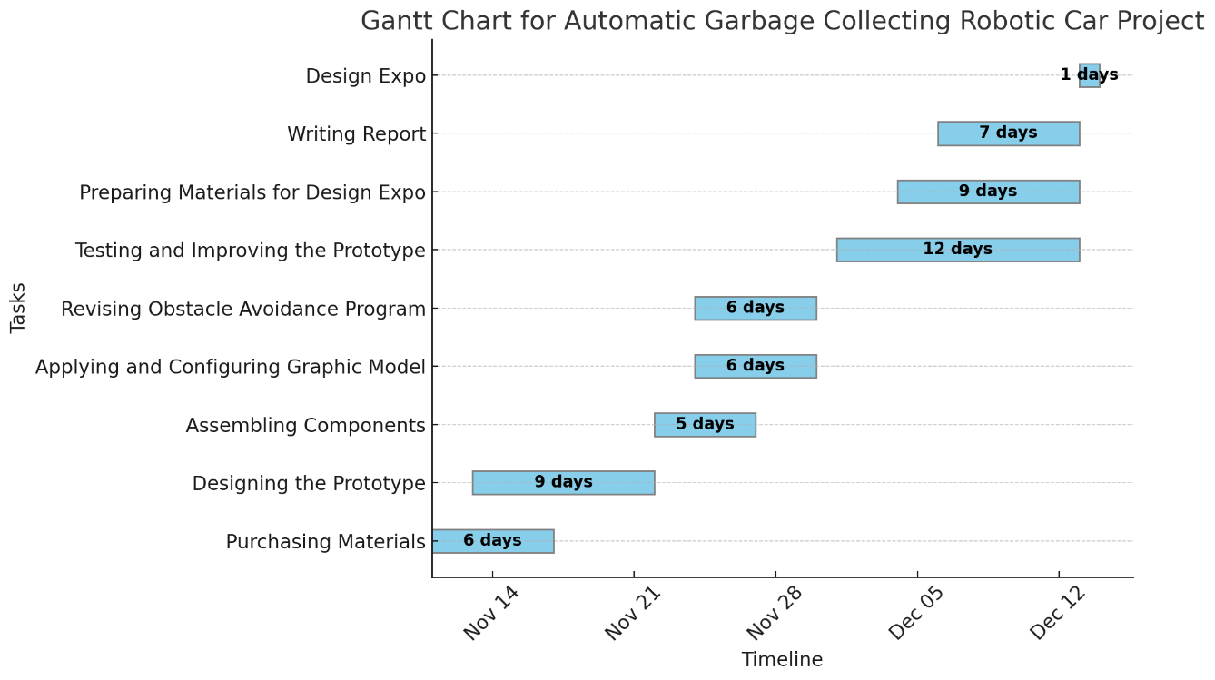

# Budget

|  |  |  |
| --- | --- | --- |
|  | Description of Work | Anticipated Costs |
| Task 1 | Trash bin | 1.00 |
| Task 2 | 3D-print body of the robot | 16.00 |
| Task 3 | Arduino Uno board | 10.00 |
| Task 4 | Ultrasonic sensor | 0.20 |
| **Task 5** | Maixduino demo board | 33.50 |
| **Task 6** | stepping motor | 5.00 |
| **Task 7** | DC motor | 1.00 |
| **Task 8** | crawler belt | 5.00 |
|  | Total | $ 71.70 |

# Key Personnel

Team leader:

Chenming Ge:

Principle role: programming

Team members:

Wenjun Cheng:

Principle role: hardware assembly

Lianjie Yuan：

Principle role: designing

Chengyuan Wang:

Principle role: testing & communication

# References

References

[1] Y. Pan, M. Li, H. Guo, Y. Li, and J. Han, “Influencing factors and reduction of domestic solid waste at university dormitory in Shanghai, China,” Sci Rep, vol. 12, no. 1, p. 570, Jan. 2022, doi: 10.1038/s41598-021-04582-0.

[2] F. Simpeh and W. Shakantu, “An on-campus university student accommodation model,” JFM, vol. 18, no. 3, pp. 213–229, Jul. 2020, doi: 10.1108/JFM-03-2020-0017.

[3] H. Zhang, J. Liu, Z. Wen, and Y.-X. Chen, “College students’ municipal solid waste source separation behavior and its influential factors: A case study in Beijing, China,” Journal of Cleaner Production, vol. 164, pp. 444–454, Oct. 2017, doi: 10.1016/j.jclepro.2017.06.224.

[4] M.-H. Zhou, S.-L. Shen, Y.-S. Xu, and A.-N. Zhou, “New Policy and Implementation of Municipal Solid Waste Classification in Shanghai, China,” IJERPH, vol. 16, no. 17, p. 3099, Aug. 2019, doi: 10.3390/ijerph16173099.

[5] T. C. Kelly, I. G. Mason, M. W. Leiss, and S. Ganesh, “University community responses to on-campus resource recycling,” Resources, Conservation and Recycling, vol. 47, no. 1, pp. 42–55, May 2006, doi: 10.1016/j.resconrec.2005.10.002.

# Appendix

[Provide supporting material for your proposal here. Only supporting material may be placed here; vital information belongs in the main part of the proposal.]